The most important notes for doing and submiting CSD201 PE .
- Do not use package in projects. The files with java extension must be stored directly in the folder src, The data.txt file must be stored in the project folder (outside of src).
- Do note write comments in programs by accented Vietnames (không dùng tiếng Việc có dấu để viết ghi chú trong chương trình). When marking, programs will be run directly (not use NetBeans), thus if a program contains accented vietnamese, error will occur and it will get 0 mark.
- Submission: Create a folder with arbitrary name, e.g. CSD_PE (2). Create subfolders according to your coded projects, e.g. if you have edited and want to submit 3 projects Q1, Q2 and Q3 then create 3 subfolders Q1R, Q2R and Q3R inside (2), and copy
MyList.java from Q1\src to Q1R  BSTree.java from Q2\src to Q2R  Graph.java from Q3\src to Q3R | 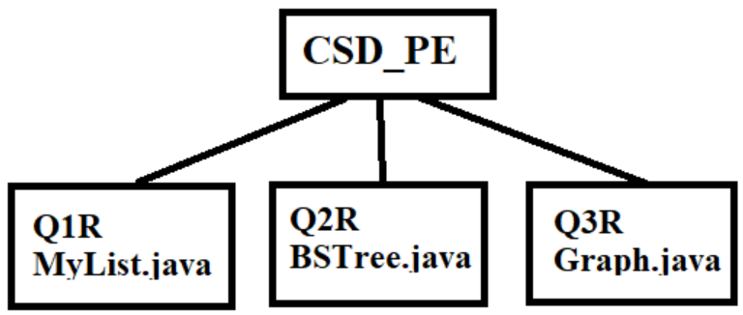
- Do not submit a file without coding, e.g. if you did not write code in given Graph.java file then you do not need to create Q3R.
- Only one submission is accepted. You can submitt more times, then the newer will overwrite the older.

